**Template for climate-related research blurbs for EOAS website**

**Please fill in this template in plain language, thank you. In this** [**document**](https://docs.google.com/document/d/1-QbcqxHapA0xjr1qaWelgVVKkrEJQekU_9N8XGivG5g/edit) **is an example for you to check out.**

1. Intro section

a. Your name [include nickname if you would like]: Abhinab Kadel (pronounced: Avinab)

[If you haven’t already, please upload your picture onto the EOAS website]

b. Position in EOAS (MSc/PhD student, Postdoc, Research scientist, Prof, etc): MSc Student (Weather Forecast Reseearch Team)

c. Why did you become a [your research field] scientist (in 1-3 sentences): My background is in renewable energy. As the raw materials for renewable energy is highly dependent on weather, I was interested in learning more about weather forecasting.

d. What do you see as the main challenges towards progress on 7 areas of action outlined in the UBC Declaration of a Climate Emergency ([link](https://president.ubc.ca/homepage-feature/2019/12/05/climate-emergency-declaration/) or see list at end of this document)? With increasing number of incoming students every year, I expect there to be increasing pressure on UBC to ensure that there is good quality of services without increasing the carbon footprint drastically.

e. What gives you hope for progress on these challenges? (in 1-3 sentences): The Climate emergency declaration and formation of Climate Emergency Advisory Committee are good first steps to address this challenge.

The following are optional:

e. Collaborators inside EOAS: Click here to enter text.

e. Collaborators outside of EOAS: ICIMOD, Nepal

d. Funding sources: Click here to enter text.

e. Location(s) of field work: Click here to enter text.

f. Where are you from: Nepal

g. Any hobbies or other information: Sports (badminton, soccer, cricket), gaming, and reading non-fiction

h. Link to personal website, twitter etc: https://www.linkedin.com/in/abhinab-kadel-563973133/

h. Anything additional you want to add? Click here to enter text.

2. Research section (if references are used, please use superscripts and fill in details in part e)

**Feel free to follow this template or write 1-2 paragraphs in language for a lay audience.** Click here to enter text.

a. Short title of your research work: economic value of weather forecasts for run-of-river hydropower systems

b. Describe in language for a lay audience your research including (≤250 words) the primary research questions/goals and/or major results/implications.

Probabilistic precipitation forecasts and hydrological modelling can provide probabilities of future discharge values. Such weather forecasting products are widely used by hydropower operators such as BC Hydro1. However, they are not yet used in Nepal. Unlike BC, Nepal has a majority of electricity generation through run-of-river hydro systems. Run-of-river systems have a smaller barrier on a river/stream to divert water towards turbines. A weir does not create a lake like conventional dams do. Hence, there are limited strategies to control water flow. As there are limited possibilities for water management, I am focusing on evaluating how the forecasts could be used for different electricity markets in Nepal. The focus will be on wholesale electricity markets, i.e., trading arrangements between electricity producer and the utility.

River discharge forecasts are obtained from the streamflow forecasting tool developed by International Centre for Integrated Mountain Development (ICIMOD)2. It provides forecasts using 52 different possible scenarios. The maximum and minimum values of river flow using these different scenarios are provided for 10 days into the future. The current market provision in Nepal is to have power purchase agreements that guarantee fixed rates per energy yield for 25-30 years. My research aims to explore the utility of inflow forecasts for other market scenarios such as day-ahead trading, where hydropower operators need to declare beforehand the amount of electricity they plan to sell to the utility.

c. Describe in language for a lay audience: 1) what excites you most about your research 2) how this work is related to climate change or sustainability-related topics.

1) My research combines interdisciplinary concepts in engineering, weather forecasting and energy economics. I could learn about weather forecasting, which was a new concept for me before the graduate program. Furthermore, I could explore more about my other interests such as energy economics.

2) Renewable energy sources provide alternative to fossil fuel-based economy. Unlike nuclear and fossil fuel sources, which are highly location and technology dependent, renewable energy sources are modular, making them ideal for developing economies. Probability forecasts aim to minimize the uncertainty associated with renewable generation, expanding their integration possibilities in a community.

d. Add a schematic, conceptual cartoon or insightful image (from your work or referenced) that showcases your research:

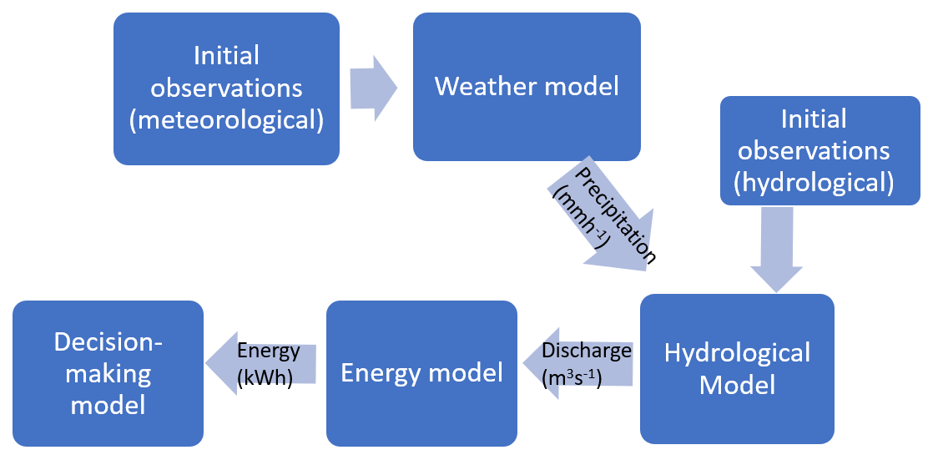

Figure : Processes involved in forecasting output of a hydro power plant.

e. Any references you used (your own work or that of others):

1. Boucher, M.A. & Ramos, M.H. (2018) Ensemble Streamflow Forecasts for Hydropower Systems. *Handbook of Hydrometeorological Ensemble Forecasting,* pp 1-19

2. ICIMOD, <https://servir.icimod.org/science-applications/streamflow-prediction-tool-nepal>. Accessed: Feb 10, 2021

3. Click here to enter text. (add more if needed)

**UBC Declaration on the Climate Emergency: Key areas of action**

*By late spring 2020, the Climate Emergency Advisory Committee will consolidate input from both in-person and online consultations into a public report that defines the pillars of climate emergency and outlines recommended actions. The report will be submitted to the new Sustainability Committee of the UBC Board of Governors for consideration. Recommendations will include but not limited to:*

1. *Increasing ambition and materially accelerating timelines for existing actions under the UBC Strategic Plan and Climate Action Plan, including adding new actions to help reduce GHG emissions beyond UBC’s current climate targets, such as emissions from travel and food.*
2. *Improving sustainability criteria for investments and asset management by UBC, including concrete commitments to move towards full divestment from fossil fuels within UBC’s controlled endowments.*
3. *Embedding climate justice into other UBC wide policies and plans that have not previously used a climate justice lens, such as policies related to health and wellbeing and investments.*
4. *Enacting climate solutions that reflect our commitment to UNDRIP and the human rights of Indigenous Peoples.*
5. *Identifying the funding and resources required to support departments and campus communities to implement their own actions to address the climate emergency.*
6. *Building just and inclusive climate solutions that work towards dismantling historic and existing barriers faced by marginalized communities.*
7. *Incorporating further actions stemming from the community engagement process and ensuring that reporting on progress is easily accessible, transparent, and accountable.*